Operating Systems Workbench V2.1
Threads (Threads and Locks) Activities and Experiments
Richard Anthony January 2005
Student name: Nguyễn Minh Đức Student ID: ITITIU21045……………...

This laboratory sheet accompanies the ‘Threads – Threads and Locks’ application within the Operating Systems Workbench.

1. Prerequisite knowledge
You should have a clear understanding of the following concepts: Operating System, Scheduling, Process, Thread.
You should have a basic understanding of the following concepts: Lock, Mutual Exclusion, Transaction.
You should be familiar with the ‘Threads – Introductory’ application within the Operating Systems Workbench.

2. Introduction
This emulation has been designed to introduce you to the fundamentals of locking and mutual exclusion whilst keeping the complexity low.
Transactions can be executed with and without locks. You can choose at what point within a transaction to apply a lock, and at what point to release a lock. You can witness the ‘lost-update’ problem in action and can correct the problem by applying locks appropriately to ensure mutually exclusive access to a shared variable.
Two threads can be executed separately or simultaneously. Each thread executes update transactions (one decrements a variable, the other increments it). Without locking, the transactions of the two threads can interfere with each other.

Figure 1 shows the Threads (Threads and Locks) interface during an emulation in which both threads are concurrently accessing the shared variable without using locks.

The display is divided into a number of sections. Each section is briefly explained:
- The ‘ADD’ Thread – This thread executes a sequence of one thousand update transactions on a shared variable. Each transaction reads the current value into thread-local storage, increments the value locally, and then writes the new value to the shared variable. There is a button to permit running this thread independently. A transaction counter is updated to allow monitoring of progress.
- The ‘SUBTRACT’ Thread – This thread executes a sequence of one thousand update transactions on a shared variable. Each transaction reads the current value into thread-local storage, decrements the value locally, and then writes the new value to the shared variable. There is a button to permit running this thread independently. A transaction counter is updated to allow monitoring of progress.
- Locking Configuration – Locking can be enabled or disabled (the default). When locking is enabled the user can elect the point during transactions at which a lock is applied on the shared variable, and the point at which the lock is released.
- Data Field (shared resource) – This shows the value of the shared variable. The value is initially 1000. A button is provided to reset the value to 1000 before re-running emulations.
- Start both threads button – This starts both threads at the same time. Since they both carry out the same number of simple updates they tend to complete at approximately the same time too (but this is not guaranteed or enforced). No synchronisation is applied to the operation of the two threads (or to their access to the shared variable) unless the user explicitly configures locking.
- Done button – This button exits the application immediately without preserving statistics or configuration settings. Control is returned to the top-level menu.

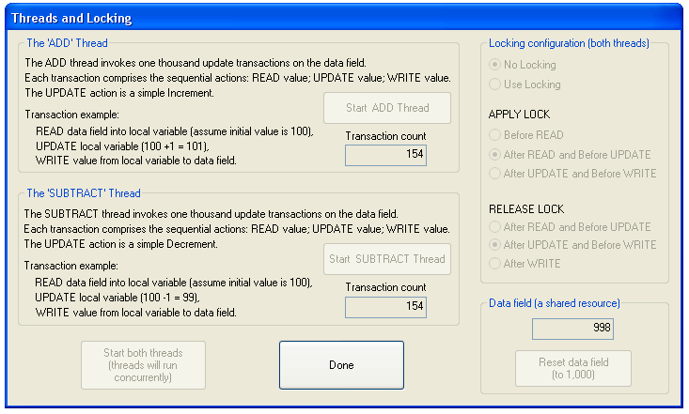

Figure 1. The Threads (Threads and Locks) interface.

The following ‘lab activities’ sections describe specific experiments and investigations to help you maximise the benefit of the software.

Please take care to read the instructions carefully for each step and try to follow instruction sequences carefully. Try to predict the outcome of experiments in advance if possible. If the outcome is not as expected try to determine why not. You can repeat experiments as often as required and can work at your own pace. Try repeating experiments with slight changes in the parameters – sometimes just changing one parameter slightly can lead to big differences in the results and can shed light on the relative importance of a particular aspect of the emulation.

For each activity the configuration settings are explained. In each case it is assumed that you have already started the ‘Introductory Scheduling Algorithms’ simulation application. To do this:
1. Start the Operating Systems Workbench.
2. From the main menu bar, select Threads.
3. From the drop-down menu, select Threads and Locks.

Lab Activity 1: Threads: Introductory: Lost-Update 1
Understanding the ‘lost-update’ problem
Threads and Locking>
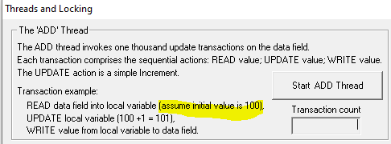

1. Inspect the initial value of the data field.
Q1. If one thousand increment updates are performed, what value should it end up at?
…...2000…………………………………………………………………………………….………

2. Click the ‘Start ADD Thread’ button to run the ADD thread in isolation.
Q2. Was the result as expected? (if not, check your maths!).
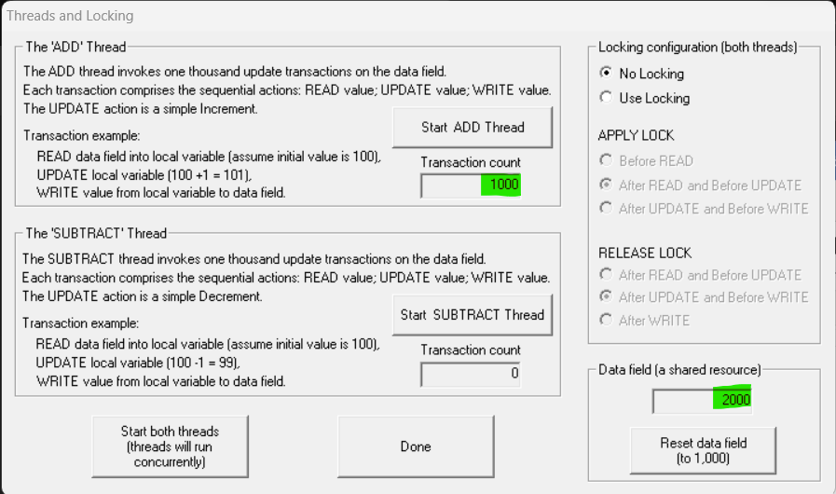
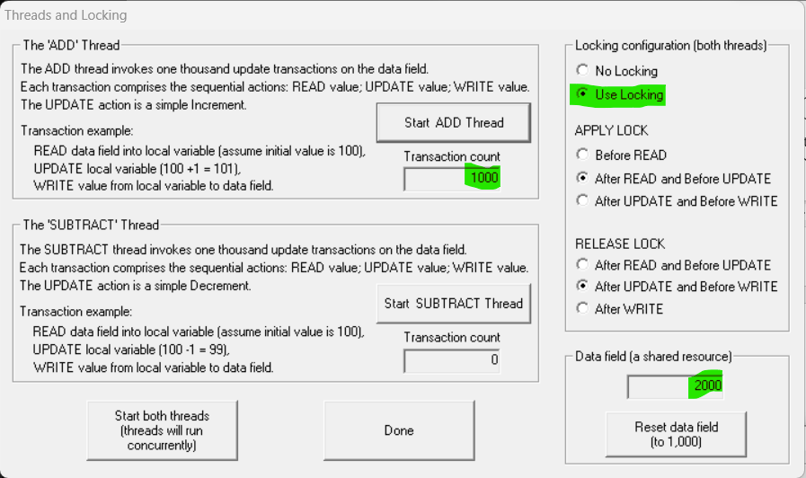
………Yes, both for the scenarios of use and no use locking…………………………….………

3. Note the value of the data field now.
Q3. If one thousand decrement updates are performed, what value should it end up at?
…………0……………………………………………………………………………….………

4. Click the ‘Start SUBTRACT Thread’ button to run the SUBTRACT thread in isolation.
Q4. Was the result as expected? (if not, check your maths!).
………… Yes, both for the scenarios of use and no use locking ………………………….………
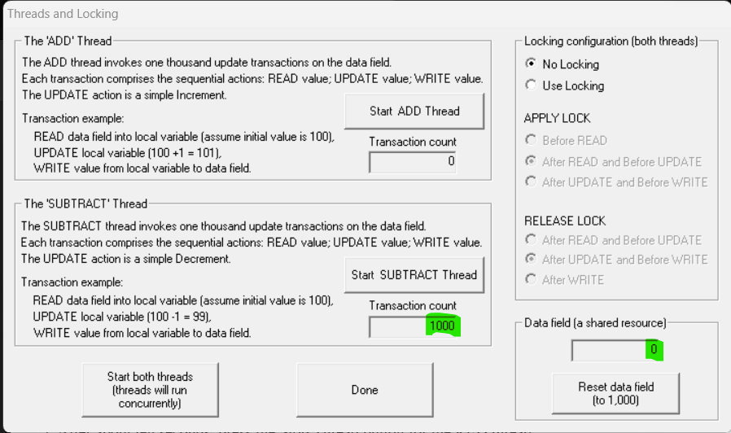
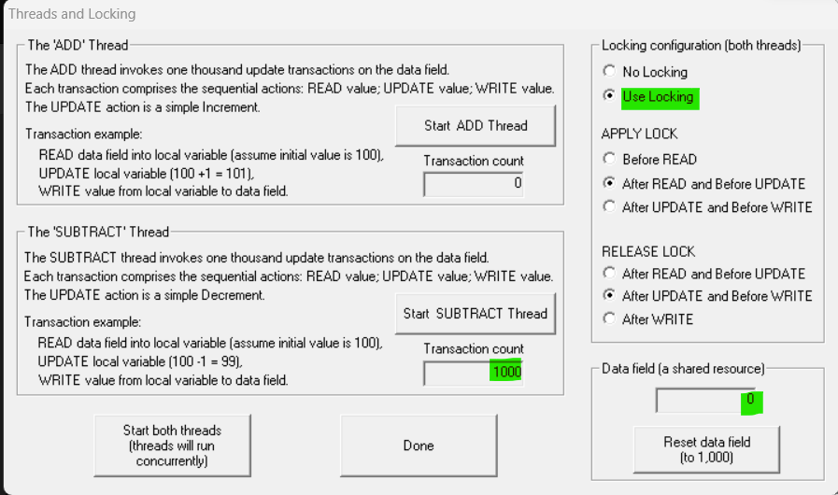

Q5. If the threads are run sequentially (as above), are there any issues concerning access to the shared variable that can lead to its corruption?
………Yes, if multiple threads are accessing and modifying a shared variable concurrently without proper synchronization, it can lead to data corruption and various issues, commonly known as a race condition…………………………………………………………………………...
5. Click the ‘Reset data field’ button to reset the value of the data variable to 1000.
Q6. Given a starting value of 1000, if one thousand increment updates are performed, and one thousand decrements are performed, what should the final value be?
…………1000………………………………………………………………………….………

6. Click the ‘Start both threads’ button to run the two threads concurrently.
7. When both threads have finished check their transaction counts to ensure both executed 1000 transactions, hence determine the correct value of the data variable.
…………1114………………………………………………………………………….………
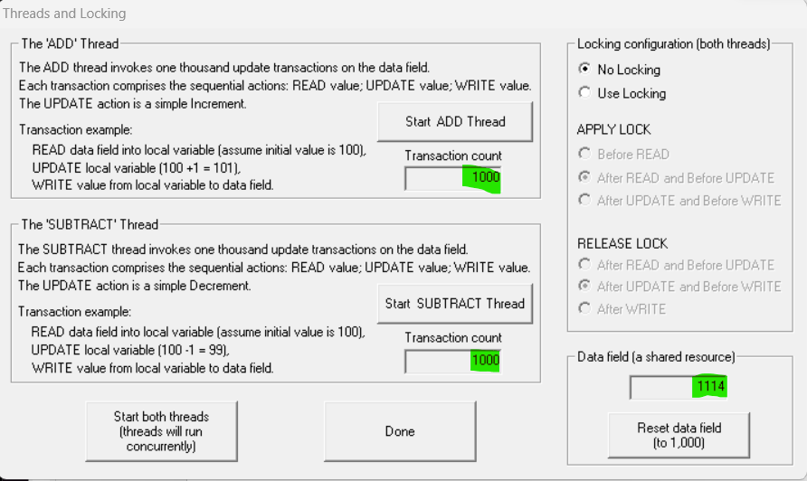
Q8. Is the actual data variable value correct? If not what could have caused the discrepancy?
………No, because of the lack of atomicity in the increment operation. The sequence of instructions from different threads can overlap, leading to unexpected and incorrect results………

Lab Activity 2: Threads: Introductory: Lost-Update 2

Understanding the ‘lost-update’ problem

The Lost-Update 1 activity exposed the lost-update problem.
We saw that a discrepancy occurred between the expected value and the actual final value of a shared variable.
Some of the updates were lost. This is because one thread was allowed to access the variable whilst the other had already started a transaction based on the value of the variable.
Q1. How does this problem relate to transactions in database applications?
……… In database applications, if multiple transactions (similar to threads from example) are allowed to read and write data concurrently without proper concurrency control mechanisms, similar issues can occur.
For example, two transactions might read the same data simultaneously, make changes based on that data, and then both try to commit their changes, resulting in lost updates or other inconsistencies.……………………………………………………………………………………

Q2. How many of the ACID properties of transactions have been violated?
………Just one and it is Isolation ………………..…………………………………….………

Q3. How could this problem affect applications such as:
An on-line flight booking system?
A warehouse stock-management system?
……For an on-line flight booking system, it may cause lost reservation (many flights can be booked at the same time), inconsistent pricing (prices and seats can be changed between the time the users try to make a reservation), etc.
For a warehouse stock-management system, inventory inaccuracy (lost updates, discrepancies between actual and recorded stock levels), inconsistent data for users (users might see different quantities, which may lead to confusion and errors in decision-making)………………………

Q4. Think of at least one other real-world application that would be affected by the lost-update problem?
…Cinema ticket-booking, online shopping order-management, courses assignment on website.….

1. Investigate if the problem has a random aspect, or if the discrepancy is predictable. Repeat the following steps three times:
A. Ensure the value of the data variable is 1000 (Click the ‘Reset data field’ button if necessary).
B. Click the ‘Start both threads’ button to run the two threads concurrently.
C. When both threads have finished check their transaction counts to ensure both executed 1000 transactions, hence determine the correct value of the data variable.
D. Make a note of the extent of the discrepancy.

1st time: 962 (Discrepancy: -38)
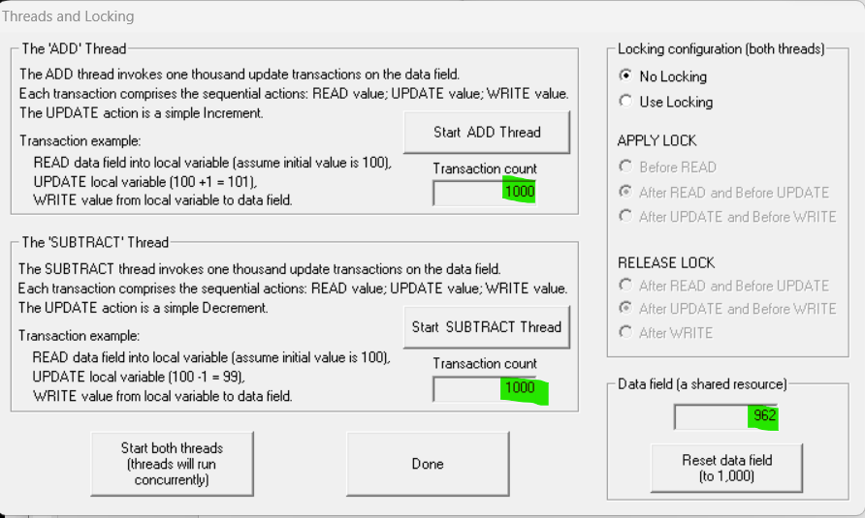

2nd time: 986 (Discrepancy: -14)
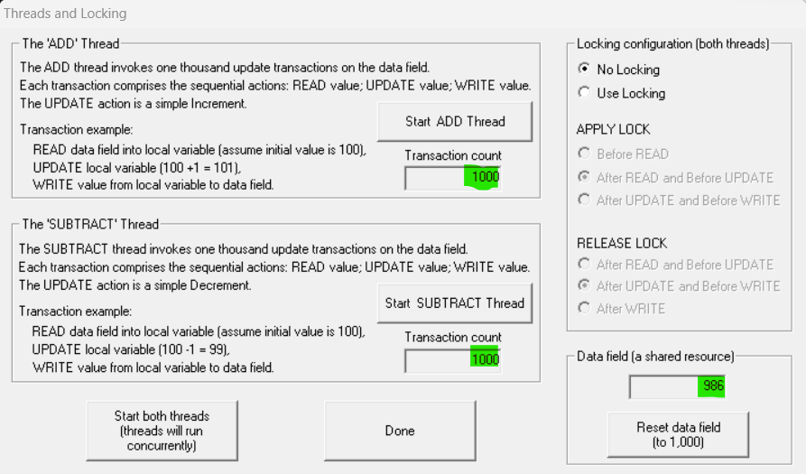

3rd time: 994 (Discrepancy: -6)
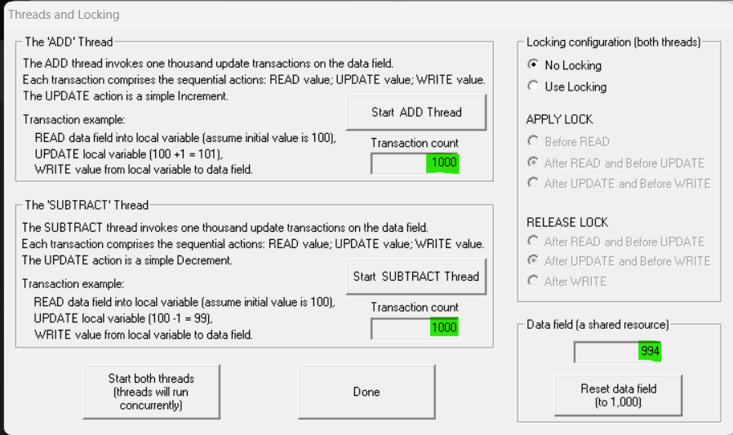

Q5. Compare the three discrepancies. Is the actual discrepancy predictable, or does it seem to have a random element?
………It seems to have a random element………………………………………………….………

Q6. If there is a random element, where does it come from (think carefully about the mechanism at play here – two threads are executing concurrently but without synchronisation – what could go wrong)?
………It comes from the the lack of atomicity in the increment operation, which is due to a race condition. The sequence of instructions from different threads can overlap, leading to unexpected and incorrect results. It also may cause interleaved execution, randomness in execution timing, unpredictable thread preemption, inconsistency in execution order, etc…………………….…...…

Q7. Is the problem more serious if the discrepancy is predictable? Or if the discrepancy is not predictable?
…… In either case, the solution remains the same: implementing proper synchronization mechanisms to ensure atomicity and consistency in concurrent operations.
Predictable discrepancies may be somewhat easier to identify, but the underlying issue of non-atomic and unsynchronized operations still needs to be addressed to ensure the application's correctness and reliability. ………………………………………………………………………….

Lab Activity 3: Threads: Introductory: Locks 1

The need for locks
The Lost-Update 1 and Lost-Update 2 activities exposed the lost-update problem, and showed us that the extent of the problem is unpredictable. Therefore, we must find a mechanism to prevent the problem from occurring.

Q1. Could a locking mechanism be the answer? If so, how would it work?
……Yes, it ensures that only one thread can access a critical section of code (which involves the shared resource) at any given time ………………………………………………………….………

Q2. Would it be adequate to apply the lock to only one of the threads, or does it have to apply to both?
……… To ensure the correct and safe synchronization of shared resources, the lock must be applied to both threads. If you apply the lock to only one of the threads, you won't achieve the desired synchronization, and race conditions may still occur. …………….……………….………

Q3. Is it necessary to use a read-lock, a write-lock, or is it important to prevent both reading and writing while the lock is applied, to ensure that no lost-updates occur (think about the properties of transactions)?
……… In the context of preventing lost updates and ensuring the integrity of shared data, the most common approach is to use a write lock (or an exclusive lock). To ensure data integrity, prevent lost updates, and align with transaction properties, a write lock (exclusive lock) is often the preferred choice when dealing with shared resources that undergo both read and write operations ..………………………………………………………………………………………….

The transactions are a sequence of three stages:
Read the current value into thread-local storage,
Increment (or decrement) the value locally,
Write the new value to the shared variable.

Q4. At what point in this sequence should the lock be applied to the transaction?
……… The lock should be applied during the entire sequence to ensure the atomicity of the entire transaction. This ensures that the entire sequence is treated as a single, indivisible operation, preventing interleaving of operations by other threads……………………..………

Q5. At what point should the lock be released?
……… The lock should be released after the entire transaction is completed. This means releasing the lock after the write operation, ensuring that the critical section protected by the lock is only held for the duration of the atomic transaction…………………………………………..

Investigate the various combinations of locking strategies:
1. Click the ‘Use Locking’ button.
2. Repeat the following steps until all combinations of lock apply and release have been tried:
A. Ensure the value of the data variable is 1000 (Click the ‘Reset data field’ button if necessary).
B. Select an option from the APPLY LOCK choices.
C. Select an option from the RELEASE LOCK choices.
D. Click the ‘Start both threads’ button to run the two threads concurrently.
E. When both threads have finished check their transaction counts to ensure both executed 1000 transactions, hence determine the correct value of the data variable.
F. Make a note of the extent of the discrepancy.
Q6. Have you found a combination of applying and releasing locks that always ensures that there is NO discrepancy? Are you sure – repeat the emulation with these settings a few times – does it ALWAYS work?
………Yes, that is APPLY LOCK BEFORE READ and RELEASE LOCK AFTER WRITE……

The use of the lock forces mutually exclusive access to the variable.
Q7. Could you explain clearly to a friend what the above statement means – try it?
…… Imagine I have a shared piggy bank (let's call it "counter") that me and my friend both want to put coins into. Now, I want to make sure that when me or my friend puts a coin into the piggy bank, nobody else can interrupt it at the same time.
Now, the "lock" is a magical key that only one person can have at a time. When I have the key, it means I’m in charge of the piggy bank. So, when I’m about to put a coin in, I grab the key (acquire the lock), do my thing (read, increment, and write), and then I give the key back (release the lock).
Here's where the "mutually exclusive access" comes in. While I have the key, my friend can't grab it and vice versa.
So, by using the lock, we make sure that any action (like putting a coin into the piggy bank) is done separately, not at the same time.

Mutual exclusion prevents the lost-update problem.
Q7. Could you explain clearly to a friend what the above statement means – try it?
……… Imagine I and my friend are both keeping track of the score in a game on a shared piece of paper. The score is initially 0. Now, we both try to update the score simultaneously because something exciting happened in the game.
Without mutual exclusion, it's like we are trying to write the new score on the paper at the same time. Here's where the lost-update problem can occur. When I see the score is 0 and want to add 1 because my team scored a point. At the same time, my friend also sees the score is 0 and wants to add 2 because something else exciting happened on their end. We both write your new scores on the paper at the same time.
Now, instead of the score being 1 (my update) or 2 (my friend's update), we end up with a mix of both, like 1+2=3. The original scores are lost, and we have this weird, incorrect total.
Now, imagine using a "lock" as a rule: only one of us can write on the paper at a time. If I want to update the score, I first grab the lock, update the score, and then give the lock back and so as my friend.
With this rule (mutual exclusion), we can make sure that only one person can update the score at any given time. This prevents the lost-update problem because there's no chance of your updates getting mixed up……………………………………………………………………………………

Threads (Introductory) Activities and Experiments
Richard Anthony January 2005

This laboratory sheet accompanies the ‘Threads – Introductory’ application within the Operating Systems Workbench.

1. Prerequisite knowledge
You should have a basic understanding of the following concepts: Operating System, Scheduling, Process, Thread.

2. Introduction
This simulation has been designed to introduce you to the fundamentals of multi-threading and thread scheduling whilst keeping the complexity low. Up to three threads can be executed simultaneously. Each thread is associated with a colour (red, green and blue). Each thread will try to increase its colour intensity of randomly chosen pixels.
You can investigate the differences between executing a single thread and executing multiple threads. You can investigate the differences between synchronous scheduling and asynchronous scheduling of threads. You can investigate the effect of priority on the scheduling.

Figure 1 shows the Threads (Introductory) interface during an emulation of asynchronous scheduling of three threads each with normal priority.

The display is divided into a number of sections. Each section is briefly explained:
- Schedule Threads Asynchronously (under Operating System control) – The emulation enables configuration of up to three threads to be scheduled for concurrent execution. Threads can be created, started and stopped (destroyed) independently.
- Priority – The priority can be set independently for each thread. The options provided are similar to those typically available to software developers. HIGHEST priority would usually be only used if the thread had a real-time processing requirement. LOWEST priority would be used for threads that run in the background and do not need to be responsive to users. Most threads would be scheduled with the NORMAL priority (the default).
- Schedule Threads Synchronously (under control by the application’s Main thread) – The emulation enables the three threads to be scheduled for synchronous execution (The threads each execute for a short time, in sequence. The overall effect is that all threads get regular turns to run – in a round-robin fashion, but this much coarser-grained than the round-robin scheduling associated with asynchronous scheduling). Threads are created (and started) and stopped (destroyed) collectively.
- Interpretation of priority for synchronous threads – The operating system’s internal mechanism can be used (however, note that with synchronous scheduling only one thread ever executes at a time as far as the operating system is concerned). Alternatively, priority can be imposed externally (within the application). In both cases the actual priority values for each thread are taken from the priority settings discussed earlier.
- Drawing canvas – This area of the display contains a large number of pixels that the threads compete to colour. The real-time thread-scheduling behaviour can be evidenced in terms of the relative success of the threads (a thread that is given a greater share of CPU time will manage to colour more of the pixels).
- Reset drawing canvas button – This paints the entire drawing canvas black, without changing other settings. It is useful when experiments need to be repeated.
- Cancel button – This button exits the application immediately without preserving statistics or configuration settings. Control is returned to the top-level menu.

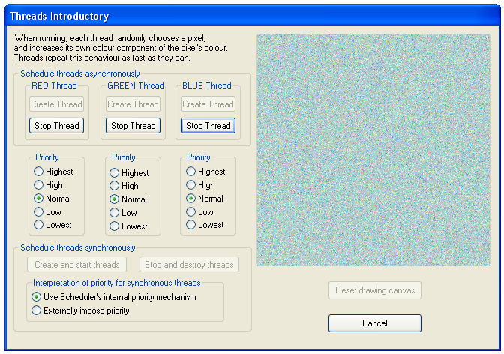

Figure 1. The Threads (Introductory) interface.

The following ‘lab activities’ sections describe specific experiments and investigations to help you maximise the benefit of the software.

Please take care to read the instructions carefully for each step and try to follow instruction sequences carefully. Try to predict the outcome of experiments in advance if possible. If the outcome is not as expected try to determine why not. You can repeat experiments as often as required and can work at your own pace. Try repeating experiments with slight changes in the parameters – sometimes just changing one parameter slightly can lead to big differences in the results and can shed light on the relative importance of a particular aspect of the emulation.

For each activity the configuration settings are explained. In each case it is assumed that you have already started the ‘Introductory Scheduling Algorithms’ simulation application. To do this:
1. Start the Operating Systems Workbench.
2. From the main menu bar, select Threads.
3. From the drop-down menu, select Introductory.

Lab Activity 4: Threads: Introductory: Single Thread
Introduction to the Introductory Threads application

1. In the ‘Schedule Threads Asynchronously’ section press the Create Thread button for the RED thread.

2. Press the Start Thread button for the RED thread.

Q1. What happens?
……The canva is gradually filled with red dots until the canva turns completely red……………………..

3. When the drawing canvas has turned completely red, press the Stop Thread button for the RED thread.

Q2. Why were the pixels not coloured evenly (why did some take longer to be coloured red than others)?

…………It may because of the thread scheduling variability, resource contention, concurrency control mechanisms, asynchronous I/O or external dependencies…………………………………….

Lab Activity 5: Threads: Introductory: Two Threads
Introduction to the Introductory Threads application

A pixel can be any one of a very large number of colours. This is because the density of each primary colour is represented as a number in the range 0 – 255. Thus, a pixel’s colour is actually described using three numbers in the format:
pixel colour = (R, G, B)
Where R is the density of the Red colour, G is the density of the Green colour and B is the density of the Blue colour.
For example (255,0,0) gives a bright red, (0,0,0) is black and (150,150,0) is orange.

The threads each choose a pixel at random and increase the density of their own colour. They also reduce the density of the other colours.

Q1. What do you think will happen if two threads run at the same time?

1. In the ‘Schedule Threads Asynchronously’ section press the Create Thread button for the RED thread.

2. In the ‘Schedule Threads Asynchronously’ section press the Create Thread button for the GREEN thread.

3. Press the Start Thread button for the RED thread.

4. After a short time (about three seconds) press the Start Thread button for the GREEN thread.

Q2. What happens?

……The canva is gradually filled with red and green dots until the canva are completely filled…………………………………………………………………………………………………………..

4. After about twenty seconds, press the Stop Thread button for the RED thread.

Q3. What happens?

……The remaining empty space in the canva is gradually filled with green dots (overdraw on red dots) until the canva are completely green……………………………………………………………………….

Lab Activity 6: Threads: Introductory: Three Threads
Introduction to the Introductory Threads application

Q1. What do you think will happen if three threads run at the same time? What colour will the drawing canvas appear to be?

1. In the ‘Schedule Threads Asynchronously’ section press the Create Thread button for the RED thread.

2. In the ‘Schedule Threads Asynchronously’ section press the Create Thread button for the GREEN thread.

3. In the ‘Schedule Threads Asynchronously’ section press the Create Thread button for the BLUE thread.

4. In quick succession, Press the Start Thread button for each of the threads.

Q2. What happens?
……The canva is gradually filled with red, green, and blue dots until the canva are completely filled………………………………………………………………………………………………………….

5. After about ten seconds, press the Stop Thread button for the RED thread.

Q3. What happens?
……The remaining empty space in the canva is gradually filled with green and blue dots (overdraw on red dots) until the canva are completely filled with green and blue dots ………………………………….

6. After another ten seconds, press the Stop Thread button for the GREEN thread.

Q4. What happens?

……The remaining empty space in the canva is gradually filled with blue dots (overdraw on red and green dots) until the canva are completely blue………………………………………………………….

7. You may, up until this point, have been answering the questions in terms of what is happening visually. Now go back over this activity and consider the questions in terms of the CPU time. Think about how the CPU time is divided between the threads that are running – how much of a share do they each get?
…. The actual share of CPU time that each thread receives depends on factors such as the number of active threads, their priorities, and the scheduling algorithm in use…………………………………….

8. Think about the scheduling of the threads – which scheduling algorithm best describes what you see happening when all three threads are running (FCFS, SJF, RR or SRJN)? (Make sure you can justify your answer).
……………..Given the scenario of three threads running concurrently without explicit details about arrival times, priorities, or burst times, and considering the possibility of time-sharing behavior, a Round Robin (RR) scheduling algorithm seems like a appropriate algorithm.
In RR, each thread is given a time slice in a cyclic order, allowing them to take turns using the CPU. This aligns with the description of all three threads running simultaneously………………………………….

Lab Activity 7: Threads: Introductory: Asynchronous vs Synchronous Thread Scheduling
Understanding the differences between Asynchronous and Synchronous Thread Scheduling

There are two main ways in which multi-threading can be supported:
- The first approach is to provide support within the Operating System (OS) (so that the OS is aware of the different threads and allocates processing time to them as appropriate). In the Introductory Threads application this is referred to as Asynchronous Thread Scheduling because the interleaving of the threads is fine-grained (as with process scheduling).

- The second approach is to manage the thread scheduling within applications themselves (this is really a simulation of threading rather than the real thing, but it can have a similar effect). The OS is not aware that the process contains several threads. In this case the OS simply controls the amount of processing time allocated to the process overall. Within the application, decisions must be made as to when to start and stop each ‘thread’. In the Introductory Threads application this is referred to as Synchronous Thread Scheduling because the interleaving of the threads is more coarse-grained (the threads appear to run in turns rather than all at once).

Experiment with the two different modes of scheduling provided. Use three threads in each case and do not alter the priority settings.
Q1. Can you clearly see the difference between the two modes of scheduling in terms of the thread behaviours? To confirm this, think how you would clearly explain what is happening to a friend?

Asynchronous Thread Scheduling (OS-Aware):
Fine-Grained Interleaving:

- Threads are managed by the operating system, which is aware of their existence and can switch between them at a fine-grained level.
- The OS can interrupt a running thread and switch to another, allowing multiple threads to progress concurrently.
Automatic Context Switching:

- The OS performs context switching automatically, deciding when to pause one thread and start another.
- Threads may run concurrently or with minimal time gaps between their execution, providing the appearance of simultaneous execution.
OS Controls Processing Time Allocation:

- The OS is responsible for allocating processing time to each thread based on its scheduling algorithm and priority settings.
- Threads run independently, and the OS ensures fair access to CPU time for each.

Synchronous Thread Scheduling (Application-Managed):
Coarse-Grained Interleaving:

- Thread scheduling is managed within the application itself, and the OS is not aware of the individual threads.
- The application explicitly controls when each thread starts and stops, resulting in a more coarse-grained interleaving of thread execution.
Explicit Thread Management:

- The application decides when to switch from one thread to another. Threads may be given turns to execute in a predetermined order or based on certain conditions within the application logic.
Limited Concurrency:

- Since the OS is not managing threads individually, there may be limitations on true concurrency. Threads might appear to run in turns, and explicit coordination is needed to achieve simultaneous progress.

Explaining the Difference to a Friend:
Asynchronous Scheduling:
"In this mode, it's like a well-organized party where everyone is dancing independently, but the DJ (the operating system) decides exactly when to switch between dancers seamlessly. It's dynamic, and each dancer gets their fair share of time on the dance floor, creating a lively and coordinated atmosphere."
Synchronous Scheduling:
"Here, it's more like a dance-off where the choreographer (the application) decides when each dancer takes the stage. They might take turns in a specific order, and the dance moves are more structured. While it might seem like they're dancing together, it's more coordinated and organized, with the dancers waiting for their designated turn."

Q2. In which mode is it easiest to see that there are separate threads running?
Asynchronous, because it is easier to observe that threads are running concurrently because the operating system dynamically interleaves their execution, leading to a more fluid and dynamic display of simultaneous activities and asynchronous mode makes it easier to visually discern and appreciate the simultaneous execution of separate threads.

Q3. Which mode would be suitable for an application in which each thread dealt with a different query, such as a web-server? Why?
For a web server application where each thread handles different queries independently, the Asynchronous Thread Scheduling (OS-Aware) mode is more suitable.
This mode allows fine-grained interleaving, automatic context switching, and independent thread execution, enabling concurrent processing of multiple queries and ensuring dynamic responsiveness to user requests. It is well-suited for scalable and efficient handling of diverse query workloads.

Lab Activity 8: Threads: Introductory: Thread Priority
Understanding Thread Priority in both Asynchronous and Synchronous Thread Scheduling

The mechanism of priority is handled differently in each of the two thread scheduling modes:
- In Asynchronous Thread Scheduling the Operating System (OS) is in control. The priority value is assigned to threads by the OS. This means that the OS will take the priority value into account automatically when deciding how much processing time to give to each thread.
- In Synchronous Thread Scheduling the OS only knows about the process itself (only one thread per process is really ever running at a time). Because of this the OS assigned priority values operate at the process level and have no effect on the relative priority of the threads within the process. To get around this, it is possible to externally alter the priority of specific threads within the application itself.

Asynchronous Thread Scheduling.
1. Create and Start three threads. Experiment with various priority configurations.

Q1. What is the visual effect of increasing a thread’s priority?
- Increased CPU Time
- Reduced Wait Time
- Preemption of Lower-Priority Threads
- Potential Starvation of Lower-Priority Threads
- Priority Inversion
Q2. What actually causes this visual effect (in terms of the thread scheduling)?
The visual effects of increasing a thread's priority are caused by the priority-based thread scheduling in the operating system. When a thread's priority is raised, it receives preferential treatment in CPU time allocation. This results in more frequent and potentially longer execution periods, as well as the possibility of preempting lower-priority threads.

Q3. What is the effect of uniformly increasing the priority of ALL threads to HIGHEST? What is the effect uniformly decreasing the priority of ALL threads to LOWEST? What is the effect of setting one thread’s priority to HIGH and setting the other two threads’ priority to LOW? (try also other configurations).
ALL threads to HIGHEST: Increased Priority for All, Potential Starvation, Reduced Fairness
ALL threads to LOWEST: Decreased Priority for All, Potential for Increased Wait Times, Fairness in Resource Allocation
Setting one thread’s priority to HIGH and setting the other two threads’ priority to LOW: Prioritizing One Thread, Potential Starvation of Lower-Priority Threads, Increased Responsiveness for High-Priority Thread

Q4. Based on your evaluation of the answers to Q3, do you think the priority settings have an:
relative, absolute or relative and absolute
effect on the threads within a single process?

Relative and absolute effect
Relative Effect:
- Changing the priority of one thread relative to another within the same process establishes a hierarchy.
- This relative hierarchy influences the scheduling decisions made by the operating system or scheduler.

Absolute Effect:
- The priority assigned to each thread has an absolute impact on the thread's position in the overall system priority hierarchy.
- This absolute priority determines how critical a thread is compared to threads from other processes.

Synchronous Thread Scheduling.
2. Create and Start the threads. Experiment with various priority configurations, USING THE SCHEDULERS INTERNAL PRIORITY MECHANISM.

Q5. What is the visual effect of increasing a thread’s priority? Why is this?
Increasing a thread's priority in synchronous thread scheduling results in more frequent and responsive execution. The higher priority gives the thread precedence in the scheduler's queue, leading to reduced wait times and increased overall activity. This visual effect is achieved through the application's explicit control over thread priorities within the internal priority mechanism of the scheduler.
This is because of Priority Influence on Scheduling, Resource Allocation Preference, Improved Responsiveness, Priority-Based Fairness.

3. Create and Start the threads. Experiment with various priority configurations, USING EXTERNALLY IMPOSED PRIORITY.

Q6. What is the visual effect of increasing a thread’s priority? Why is this?
- Increased Execution Priority
- Preemption of Lower-Priority Threads
- External Influence on Execution Order

Q7. What actually causes this visual effect (in terms of the thread scheduling)?
- Priority-Based Scheduling Algorithm
- Thread Prioritization
- CPU Time Allocation
- Preemption
- Starvation
- Priority Inversion

Q8. What is the effect of uniformly increasing the priority of ALL threads to HIGHEST? What is the effect uniformly decreasing the priority of ALL threads to LOWEST? What is the effect of setting one thread’s priority to HIGH and setting the other two threads’ priority to LOW? (try also other configurations).
ALL threads to HIGHEST: Increased Priority for All, Potential Starvation, Reduced Fairness
ALL threads to LOWEST: Decreased Priority for All, Potential for Increased Wait Times, Fairness in Resource Allocation
Setting one thread’s priority to HIGH and setting the other two threads’ priority to LOW: Prioritizing One Thread, Potential Starvation of Lower-Priority Threads, Increased Responsiveness for High-Priority Thread

Q9. Based on your evaluation of the answers to Q8, do you think the priority settings have an:
relative, absolute or relative and absolute
effect on the threads within a single process?
Relative and absolute effect
Relative Effect:
- Changing the priority of one thread relative to another within the same process establishes a hierarchy.
- This relative hierarchy influences the scheduling decisions made by the operating system or scheduler.

Absolute Effect:
- The priority assigned to each thread has an absolute impact on the thread's position in the overall system priority hierarchy.
- This absolute priority determines how critical a thread is compared to threads from other processes.

